How to Create a Dialogue

1. Make sure there is a canvas object with the appropriate dialogue scripts attached. See the [Dialogue Documentation](https://drive.google.com/file/d/1GjPVoloSc3i1q8ofIYlcKyV8B7OgmS3O/view?usp=sharing) for further instructions
2. Create a dialogue object and character template object
   1. You can right click in any folder and click Create>Dialogue
      1. Same for Character Template
   2. Fill in the required fields of the object you created
3. Add the Dialogue Activator script to a game object, along with a sphere collider
   1. Make sure sphere collider has “Is Trigger” enabled/checked
4. Make sure you have properly configured the events in your player input script (within player prefab): 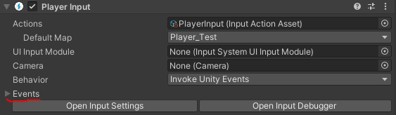
   1. Click on the “Events” dropdown and then the “Player_Test” dropdown
   2. You should see the Interact event listed: 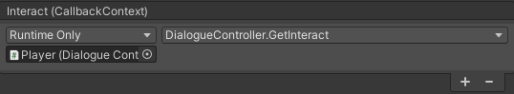
   3. Make sure it is set to the player dialogue controller script like above.
5. Your player prefab should already be set to trigger the dialogue by pressing the “Z” key when nearby. (“X” is currently set to skip conversation).